

Linnaeus University

1DV532 – Starting out with Java

Assignment 4 Report

Student: Evan Huynh

Student ID: eh223im@student.lnu.se

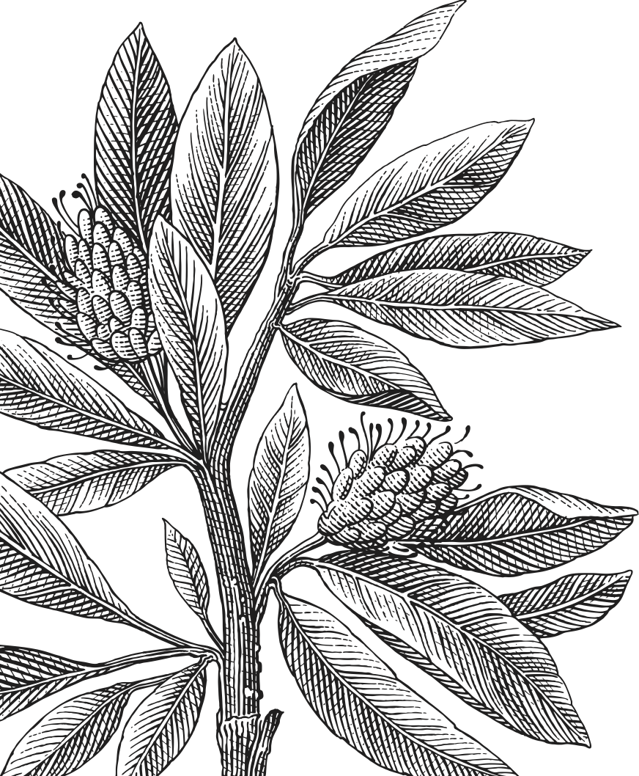

Table of Contents

Report 3

Exercise 1: Dice 3

Exercise 2: Person 3

Exercise 3: Message 3

Exercise 4: Number 3

Exercise 5: Name 4

Note 4

Source code 5

Bibliography 15

# Report

## Exercise 1: BankAccount

A

## Exercise 2: Stack

A

## Exercise 3: Polygon

A

## Exercise 4: Average

A

# Source code

Here are my source codes for all the exercise.

|  |
| --- |
|  |
|  |
|  |
|  |